**In Manager Dashboard,** we need **calendar view** and **list view** where manager can see allocated shift and unallocated shift.

Second thing, we also need **shift drop** and **swift swap notification** where manager can assign to another employee and accept employee request.

Unallocated shift means is a shift that has not been assigned to any specific employee.

When a **Shift is created** it is listed in **Un-allocated Shifts** section >> When the manager assigns that shift to an employee it goes to **Allocated Shifts** section.

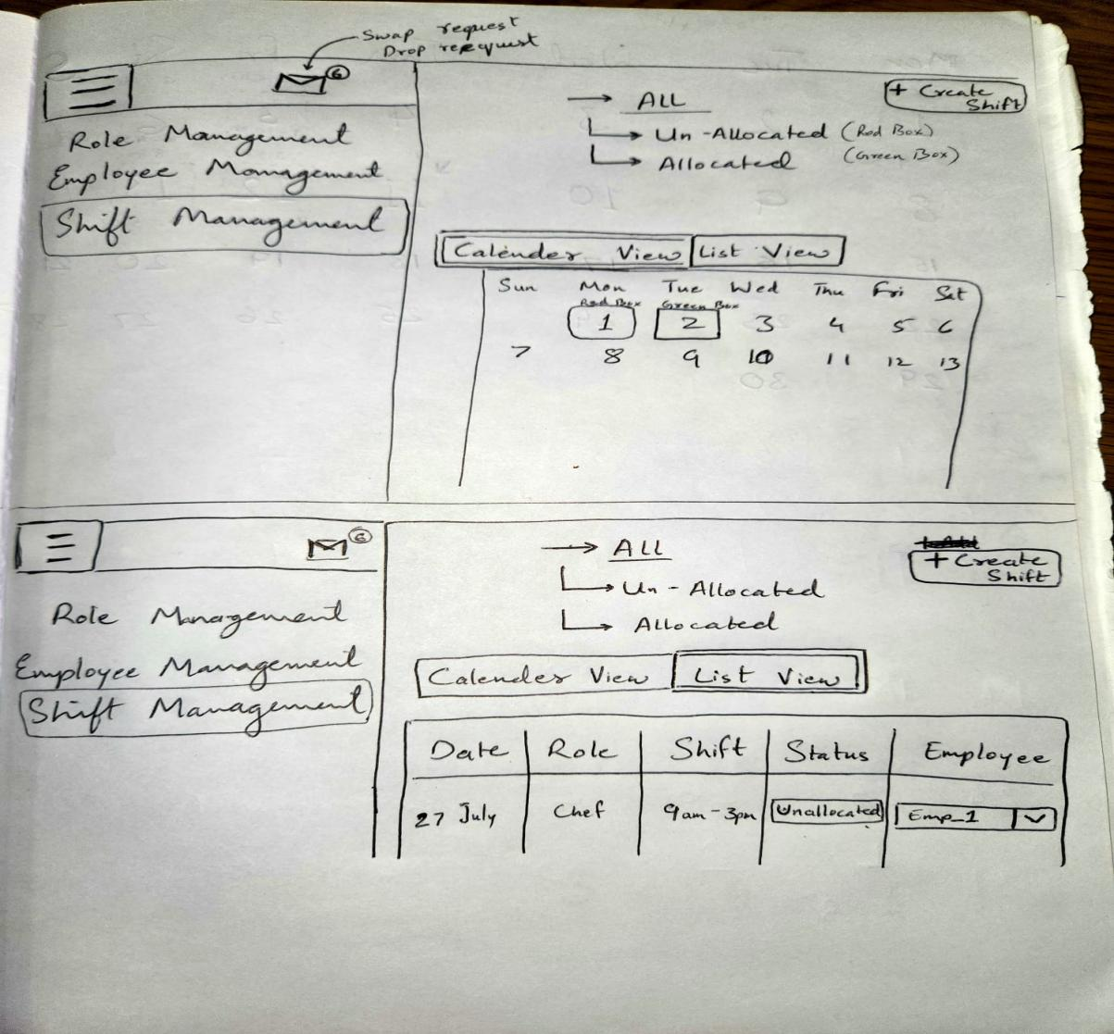

**In Employee Dashboard,** we need

1. **Your Upcoming Shifts,** where employee can see their shifts.

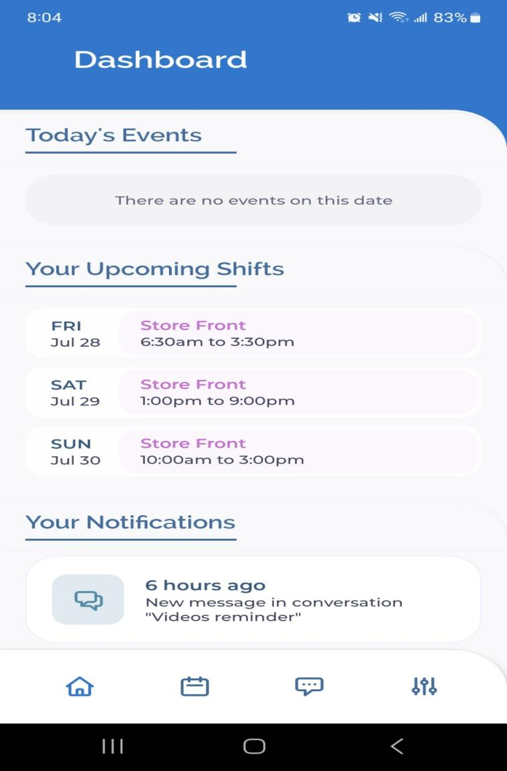

1. **Shift Drop and Bookofsf Request,** where employees might be allowed to drop a shift from their schedule within a certain timeframe, usually with the expectation that another employee will pick up the dropped shift. The dropped shift then becomes an "unallocated shift" until it is picked up by another employee.

A Bookoff Request is a formal request made by an employee to take time off from work during specific dates or for a particular shift.

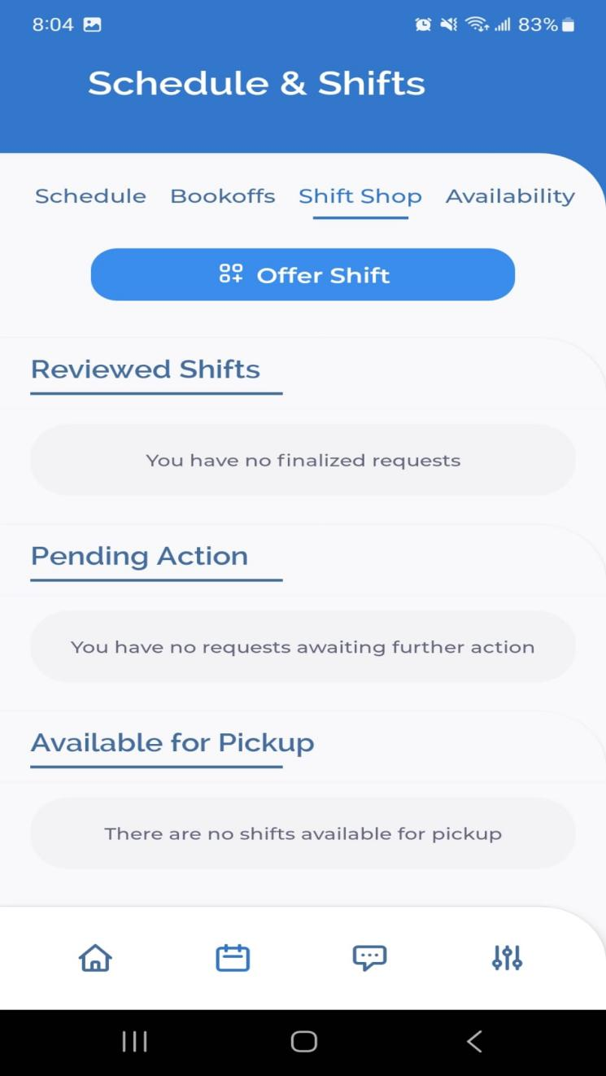

1. Availability: in this employees can upload their availability Managers can use this availability data to ensure that shifts are assigned to employees who are available and to avoid scheduling conflicts.

